Course 13 ---Tilt switch

**The purpose of the experiment:**

This lesson is ball switch experiment, it also belongs to the tilt switch just name is different. It control the turning on or off of the circuit by the rolling contact pin of the beads in the switch, so the LED can be switched on and off.

**List of components required for the experiment:**

Arduino UNO board *1

USB cable *1

220Ω resistor *1

10kΩ resistor *1

Tilt switch *1

Breadboard *1

Dupont line *1 bunch

**Actual object connection diagram：**

We need to connect the circuit as shown in the figure below.

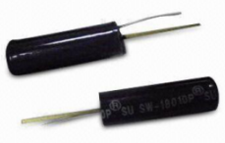

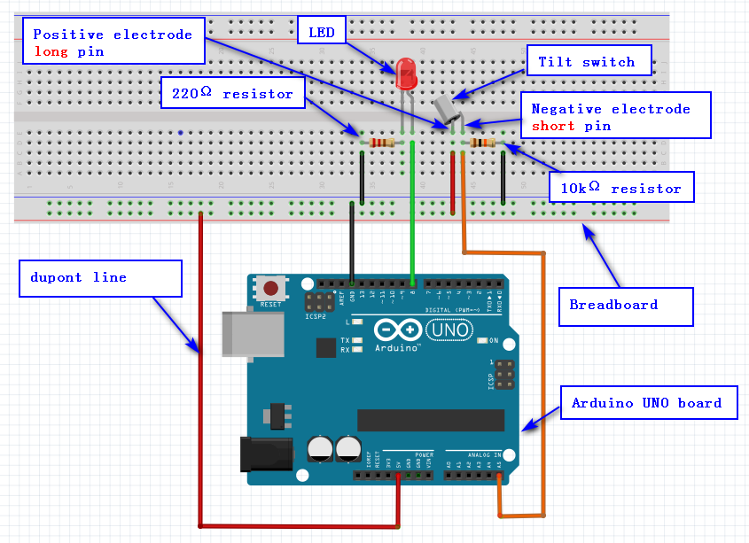**Experimental code analysis:**

int switchpin = 5;

int ledpin = 8;

int val = 0;

void setup()

{

pinMode(ledpin,OUTPUT);//Defining the led port for the output port

Serial.begin(9600);//The baud rate is 9600

}

void loop()

{

val = analogRead(switchpin);

if(val>512)//The analog voltage value of 512 is exactly 2.5V

digitalWrite(ledpin,HIGH);//If val Greater than 2.5 V

else//If val less than or equal to 2.5 V

digitalWrite(ledpin,LOW);

Serial.println(val);

}

**Experimental steps:**

1.We need to open the code of this experiment: **code-8x8_dot_matrix.ino**, click“**√**” under the menu bar to compile the code, and wait for the word "**Done compiling** " in the lower right corner, as shown in the figure below.

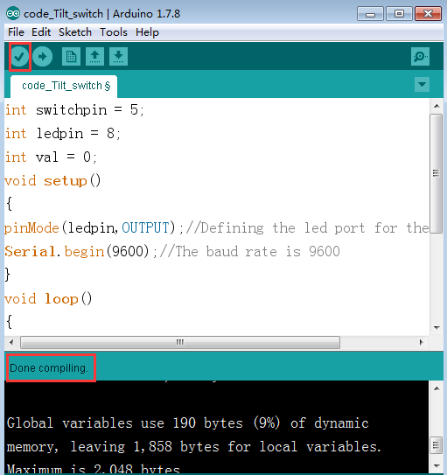

1. In the menu bar of Arduino IDE, we need to select 【Tools】---【Port】--- selecting the port that the serial number displayed by the device manager just now, as shown in the figure below. For example:COM6,as shown in the following figure.

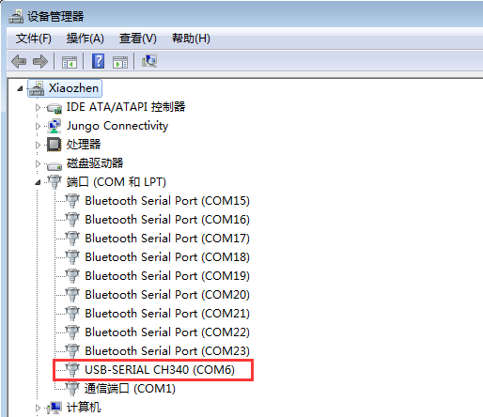

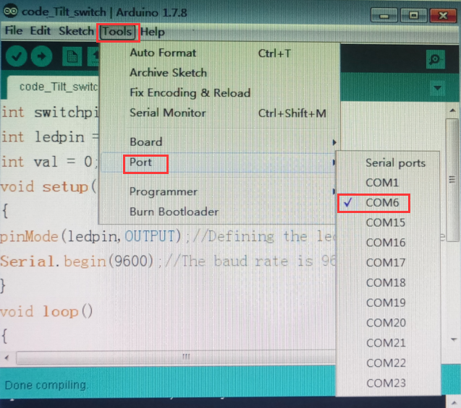

1. After the selection is completed, you need to click “**→**”under the menu bar to upload the code to the Arduino UNO board. When the word “**Done uploading**” appears in the lower left corner, the code has been successfully uploaded to the Arduino UNO board, as shown in the figure below.

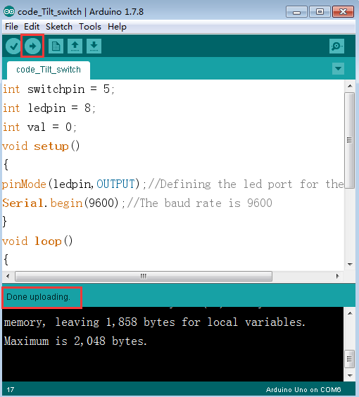

1. After the code is uploaded. The LED lights up when the ball switch is in the horizontal position, and the LED turns off when we put the ball switch in the tilt position.，At the same time, we can open the serial port monitor, we can also see the change of the voltage value at both ends of the ball switch, as shown in the figure below.

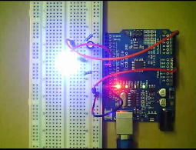 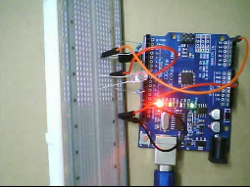

The code of the experiment: